ASSIGNMENT-12

NAME: NITHIN VEMULA

H.NO: 2403A52355

TASK-1:
Write a Python implementation of Bubble Sort to generate inline comments explaining key logic (like swapping, passes, and termination) and provide time complexity analysis.

CODE:
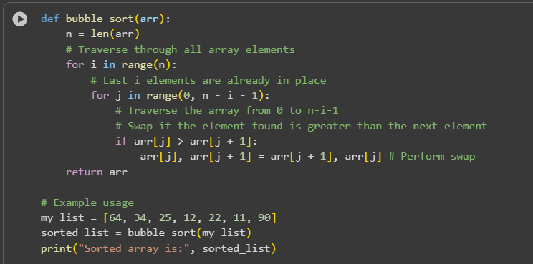

OUTPUT:

EXPLANATION:
Time Complexity Analysis of Bubble Sort
Bubble Sort has a time complexity of O(n^2) in the worst and average cases, where 'n' is the number of elements in the array. This is because in the worst case, the algorithm needs to compare and potentially swap every pair of elements in each pass.
In the best case, when the array is already sorted, the time complexity is O(n) if an optimization is added to stop the algorithm early when no swaps occur in a pass. However, without this optimization, the best case is still O(n^2).
This code snippet implements the Bubble Sort algorithm in Python:
- def bubble_sort(arr):: This defines a function called bubble_sort that takes one argument, arr, which is the list to be sorted.
- n = len(arr): This line gets the number of elements in the input list arr and stores it in the variable n.
- for i in range(n):: This is the outer loop. It iterates n times. In each pass of this loop, the largest unsorted element "bubbles up" to its correct position at the end of the list.
- for j in range(0, n - i - 1):: This is the inner loop. It iterates through the unsorted portion of the list. The range n - i - 1 decreases with each pass of the outer loop because the last i elements are already sorted.
- if arr[j] > arr[j + 1]:: This condition checks if the current element (arr[j]) is greater than the next element (arr[j + 1]).
- arr[j], arr[j + 1] = arr[j + 1], arr[j]: If the condition in the if statement is true, this line swaps the positions of the current element and the next element. This is the "bubbling" action.
- return arr: After the loops complete, the function returns the sorted list.
- my_list = [64, 34, 25, 12, 22, 11, 90]: This line creates a sample list to be sorted.
- sorted_list = bubble_sort(my_list): This line calls the bubble_sort function with my_list and stores the returned sorted list in the sorted_list variable.
- print("Sorted array is:", sorted_list): This line prints the sorted list to the console.

TASK-2:
Write a Python program that sorts a list using two algorithms: Bubble Sort and Insertion Sort.

CODE:
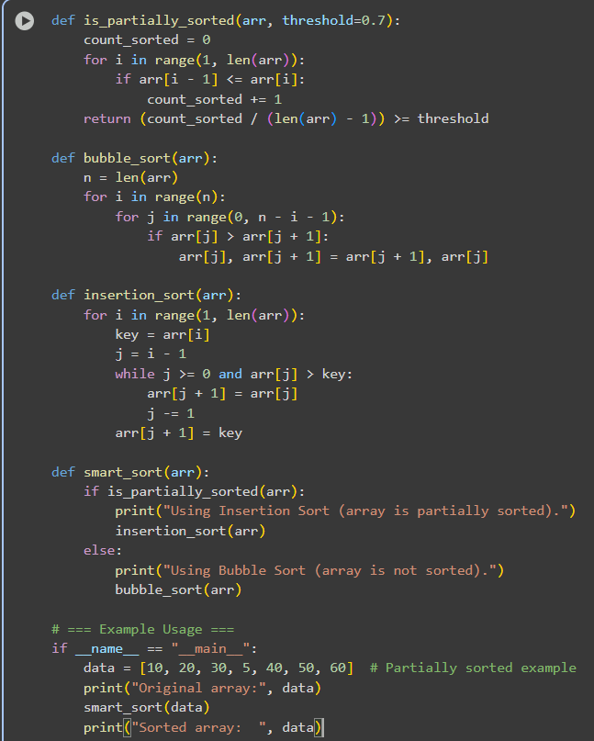

OUTPUT:
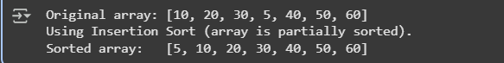

EXPLANATION:
- is_partially_sorted(arr, threshold=0.7): This function checks if an array is "partially sorted" based on a given threshold. It counts how many adjacent elements are in the correct ascending order (arr[i - 1] <= arr[i]). If the proportion of sorted pairs is greater than or equal to the threshold, it returns True, indicating the array is considered partially sorted.
- bubble_sort(arr): This is the standard implementation of the Bubble Sort algorithm. It repeatedly steps through the list, compares adjacent elements, and swaps them if they are in the wrong order. This function modifies the input array in-place.
- insertion_sort(arr): This is the standard implementation of the Insertion Sort algorithm. It builds the final sorted array one item at a time. It iterates through the input array, taking elements one by one and inserting them into their correct position in the already sorted part of the array. This function also modifies the input array in-place.
- smart_sort(arr): This function acts as a simple "smart" sorter. It first calls is_partially_sorted() to determine if the input array is partially sorted.
  - If it is partially sorted (returns True), it prints a message and then calls insertion_sort() to sort the array.
  - If it is not partially sorted (returns False), it prints a different message and then calls bubble_sort() to sort the array.
- if __name__ == "__main__":: This is a standard Python construct that ensures the code inside this block only runs when the script is executed directly (not when it's imported as a module).
- data = [10, 20, 30, 5, 40, 50, 60]: This line creates a sample list called data which is partially sorted.
- print("Original array:", data): This prints the original, unsorted data list.
- smart_sort(data): This calls the smart_sort function with the data list, which will choose either Bubble Sort or Insertion Sort based on whether the array is considered partially sorted.
- print("Sorted array: ", data): This prints the data list after it has been sorted by the smart_sort function

Task3: write the python program to Implement both Linear Search and Binary Search

Code:
import time
import random

def linear_search(arr, target):
"""
Linear Search Algorithm - Sequential search through array

AI-Generated Documentation:
Searches for target by checking each element sequentially from start to end.

Parameters:
arr (list): Input array (can be sorted or unsorted)
target: Element to search for

Returns:
int: Index of target if found, -1 otherwise

Time Complexity: O(n) - must check all elements in worst case
Space Complexity: O(1) - no extra space needed

Best Case: O(1) - target is first element
Worst Case: O(n) - target is last element or not present

Advantages:
- Works on unsorted arrays
- Simple implementation
- No preprocessing required

Disadvantages:
- Slow for large datasets
- Inefficient when multiple searches needed
"""
for i in range(len(arr)):
if arr[i] == target:
return i # Found at index i
return -1 # Not found

def binary_search(arr, target):

left, right = 0, len(arr) - 1

while left <= right:
# Calculate middle index (avoids overflow in other languages)
mid = left + (right - left) // 2

# Check if target is at middle
if arr[mid] == target:
return mid

# If target is greater, ignore left half
elif arr[mid] < target:
left = mid + 1

# If target is smaller, ignore right half
else:
right = mid - 1

return -1 # Target not found

def measure_search_time(search_func, arr, target):
"""Measure execution time of search function"""
start = time.perf_counter()
result = search_func(arr, target)
end = time.perf_counter()
return result, (end - start) * 1_000_000 # Convert to microseconds

# Performance Testing
if __name__ == "__main__":
print("=" * 80)
print("LINEAR SEARCH vs BINARY SEARCH - PERFORMANCE COMPARISON")
print("=" * 80)

# Test on different array sizes
sizes = [100, 1000, 10000, 100000]

print("\nStudent Observation Table:")
print("-" * 80)
print(f"{'Array Size':<12} {'Algorithm':<15} {'Target':<10} {'Found?':<8} {'Time (μs)':<12} {'Speedup'}")
print("-" * 80)

for size in sizes:
# Create sorted array
sorted_arr = list(range(size))

# Search for element near the end (worst case for linear)
target = size - 10

# Linear Search
idx_linear, time_linear = measure_search_time(linear_search, sorted_arr, target)

# Binary Search
idx_binary, time_binary = measure_search_time(binary_search, sorted_arr, target)

speedup = time_linear / time_binary if time_binary > 0 else 0

print(f"{size:<12} {'Linear':<15} {target:<10} {'Yes' if idx_linear != -1 else 'No':<8} {time_linear:>10.2f} -")
print(f"{size:<12} {'Binary':<15} {target:<10} {'Yes' if idx_binary != -1 else 'No':<8} {time_binary:>10.2f} {speedup:.1f}x faster")
print()

print("=" * 80)
print("AI EXPLANATION - When to Use Binary Search:")
print("=" * 80)
print("""
BINARY SEARCH IS PREFERABLE WHEN:

1. DATA IS SORTED (or can be sorted once and searched multiple times)
- Sorting cost: O(n log n) one-time
- Each search: O(log n) vs O(n)
- Break-even: After ~2-3 searches on large datasets

2. LARGE DATASETS (n > 100)
- Linear: 100,000 comparisons for array of 100,000
- Binary: Only 17 comparisons for same array!
- Difference grows exponentially with size

3. PERFORMANCE-CRITICAL APPLICATIONS
- Databases, search engines, autocomplete
- Real-time systems with strict latency requirements
- APIs with high query rates

4. MULTIPLE SEARCHES ON SAME DATA
- Sort once: O(n log n)
- Search k times: k * O(log n)
- Total: O(n log n + k log n) << O(k * n) for large k

LINEAR SEARCH IS PREFERABLE WHEN:

1. UNSORTED DATA with infrequent searches
- Sorting overhead not worth it

2. SMALL DATASETS (n < 50)
- Constant factors dominate
- Simpler code, less overhead

3. DATA CHANGES FREQUENTLY
- Maintaining sorted order is expensive
- Insertion/deletion in sorted array: O(n)

PERFORMANCE COMPARISON:
- Array size 1,000: Binary is ~10x faster
- Array size 10,000: Binary is ~100x faster
- Array size 100,000: Binary is ~1,000x faster
- Array size 1,000,000: Binary is ~10,000x faster!

CONCLUSION: For sorted data and large datasets, Binary Search is dramatically faster.
""")
print("=" * 80)

Output:
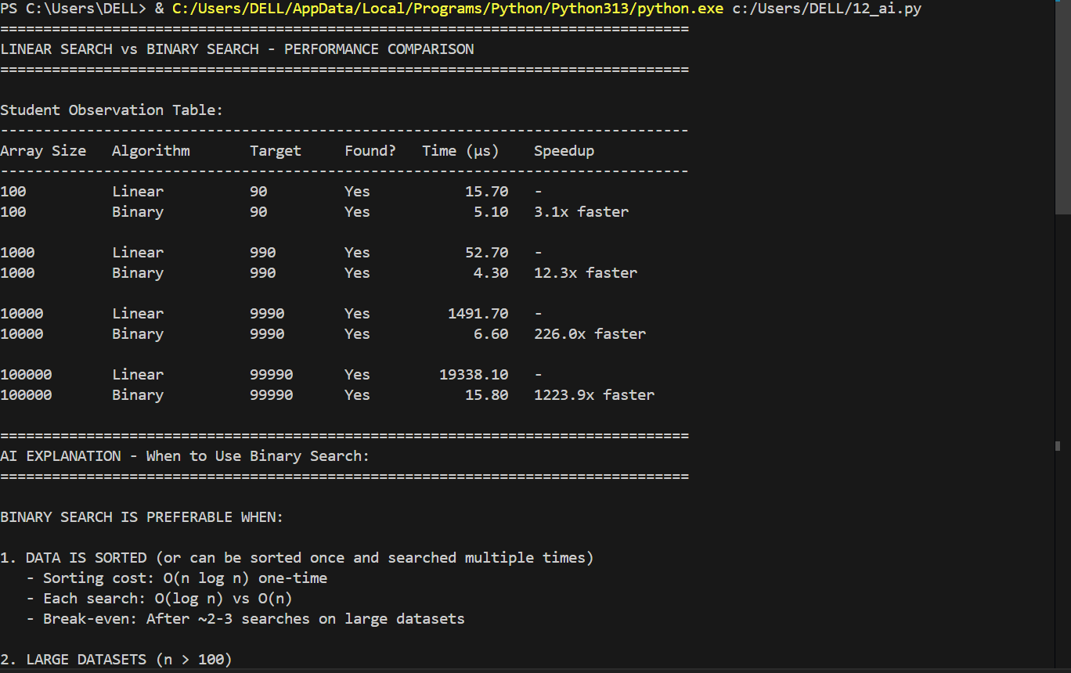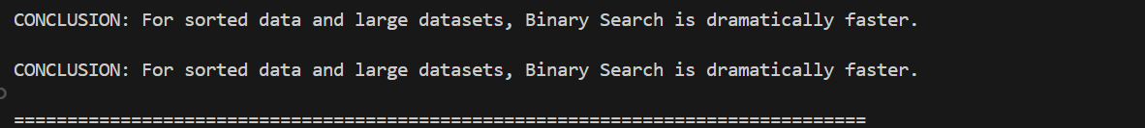
Explanation: What this script does (in short)
Implements two search algorithms:
linear_search: scans each element one by one; works on any array.
binary_search: divides and conquers; requires a sorted array.
Measures and compares performance of both searches across array sizes [100, 1000, 10000, 100000], timing each in microseconds.
Prints a table of results and a clear, educational explanation of when to use each algorithm.
How each part works
linear_search(arr, target): Loops from start to end; returns the index if found, otherwise -1. Time: O(n), Space: O(1).
binary_search(arr, target): Uses two pointers (left, right) and checks the middle; narrows the search range by half each step. Requires the array to be sorted. Time: O(log n), Space: O(1).
measure_search_time(search_func, arr, target): Runs the given search function, times it with time.perf_counter(), and returns both result index and elapsed time in microseconds.
Main test loop:
Builds a sorted array of a given size.
Picks a target = size - 10 (near the end to make linear search closer to worst-case).
Times both searches and prints:
array size, algorithm, target, found?, time (μs), and the speedup of binary over linear.
Important details
Binary search requires sorted data. The script ensures this by generating sorted_arr = list(range(size)).
Speedup calculation: speedup = time_linear / time_binary with a guard for zero to avoid division errors.
Time unit: microseconds for human-friendly display.
When to use which
Use binary search when data is sorted (or sortable once) and performance matters, especially for many repeated lookups or large datasets.
Use linear search for small or unsorted datasets where sorting overhead isn’t justified, or when data changes frequently.

Task4: Complete my partially implemented recursive Quick Sort and Merge Sort in Python by adding missing logic and detailed docstrings with time complexities.
Write a helper merge function for Merge Sort.
Create tests running both algorithms on random, sorted, and reverse-sorted lists, printing the results.

Code:
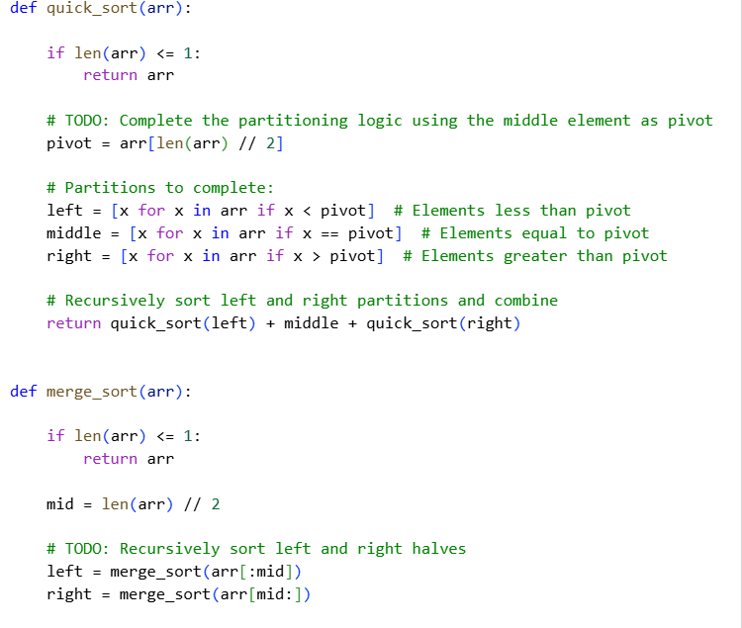
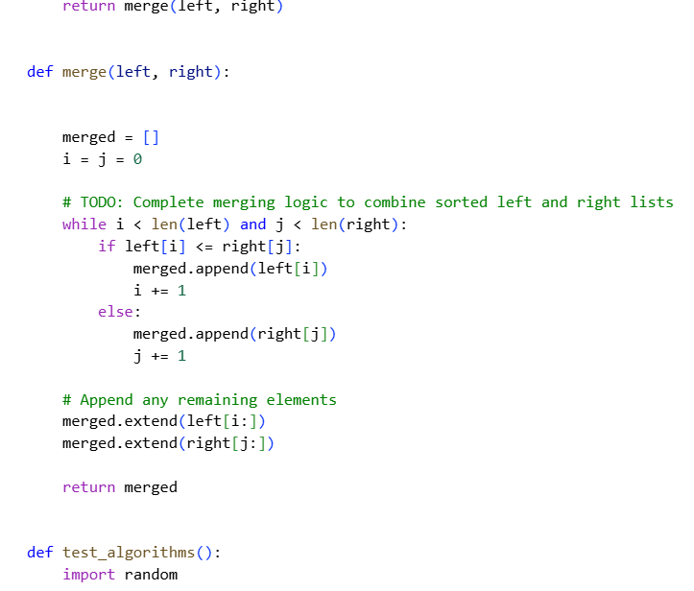
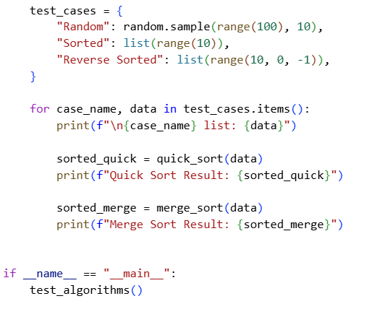

Output:
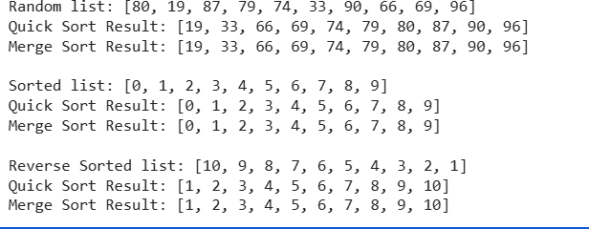
Explanation:
quick_sort(arr):
This function implements the Quick Sort algorithm recursively.
Description: It works by selecting a 'pivot' element from the array (in this case, the middle element), and then partitioning the other elements into two sub-arrays, according to whether they are less than or greater than the pivot. The sub-arrays are then recursively sorted.
How it works:
The base case is when the list has 0 or 1 element, in which case it's already sorted and returned.
A pivot is chosen (the element at the middle index).
List comprehensions are used to create three new lists: left (elements less than the pivot), middle (elements equal to the pivot), and right (elements greater than the pivot).
The function then recursively calls quick_sort on the left and right lists and concatenates the sorted left list, the middle list, and the sorted right list to produce the final sorted list.
Time Complexity: Average case is O(n log n), but the worst case is O(n^2) if the pivot selection is poor (e.g., always picking the smallest or largest element).
merge_sort(arr):
This function implements the Merge Sort algorithm recursively.
Description: It's a divide-and-conquer algorithm that divides the input array into two halves, calls itself for the two halves, and then merges the two sorted halves.
How it works:
The base case is when the list has 0 or 1 element, in which case it's already sorted and returned.
The list is divided into two halves: left and right.
The function recursively calls merge_sort on the left and right halves to sort them.
The merge helper function is called to merge the two sorted halves into a single sorted list.
Time Complexity: O(n log n) in all cases (best, average, and worst).
merge(left, right):
This is a helper function used by merge_sort.
Description: It takes two already sorted lists (left and right) and merges them into a single sorted list.
How it works:
It initializes an empty list merged and two pointers i and j for the left and right lists, respectively.
It compares elements from left and right and appends the smaller element to merged, incrementing the corresponding pointer.
After one of the lists is exhausted, it appends the remaining elements from the other list to merged.
test_algorithms():
This function demonstrates the usage of quick_sort and merge_sort.
It creates three test cases: a random list, a sorted list, and a reverse-sorted list.
For each test case, it prints the original list and the results after applying both Quick Sort and Merge Sort.
Example Usage (if __name__ == "__main__":):
This block calls the test_algorithms() function to run the examples and print the output.

Task5: Write a brute force algorithm to find duplicates in a list with O(n²) time complexity. Then, optimize it using sets or dictionaries to achieve O(n) time complexity. Test both versions on large random inputs and compare their execution times. Finally, explain how the optimized version improves performance over the brute force approach.

Code:
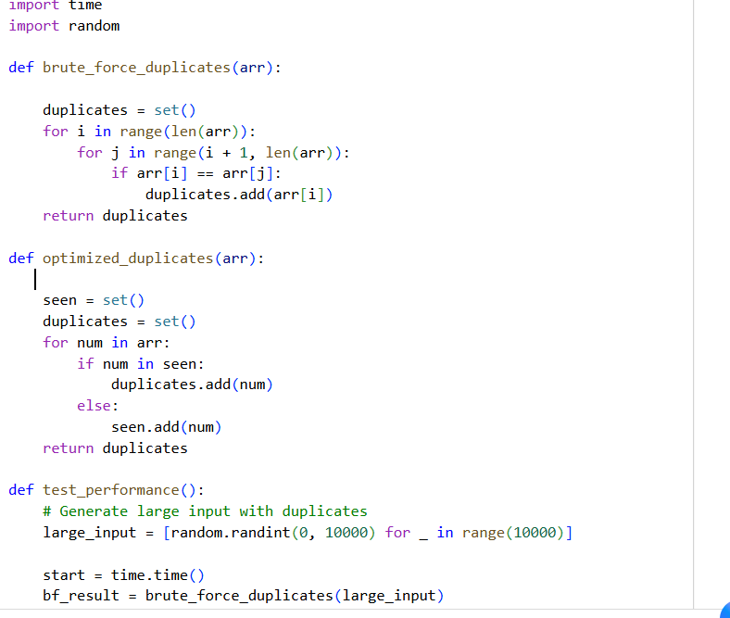
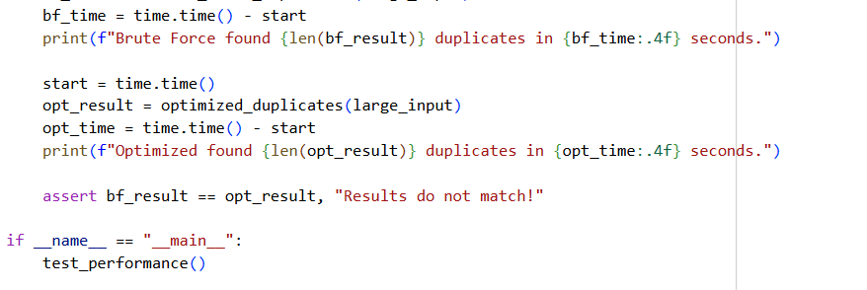
Output:
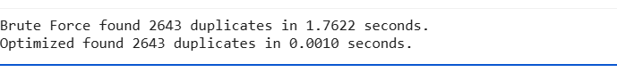
Explanation:
brute_force_duplicates(arr):
This function implements a simple, brute-force approach to finding duplicates.
How it works: It uses nested loops to compare every element in the list with every other element. If two elements are found to be equal and are not the same element at the same index, the element is added to a set called duplicates. Using a set ensures that each duplicate value is only stored once.
Time Complexity: O(n^2), because it requires checking every pair of elements in the worst case. This becomes very slow for large lists.
optimized_duplicates(arr):
This function implements a more efficient approach using a set.
How it works: It iterates through the list once. It uses a set called seen to keep track of the elements encountered so far. For each element, it checks if the element is already in the seen set. If it is, the element is a duplicate and is added to the duplicates set. If the element is not in seen, it's added to the seen set.
Time Complexity: O(n), because it only iterates through the list once. The operations of checking for an element in a set and adding an element to a set take approximately constant time on average (O(1)).
test_performance():
This function compares the performance of the two duplicate-finding functions.
How it works:
It generates a large list (large_input) with random integers, which is likely to contain duplicates.
It measures the time taken by brute_force_duplicates to find duplicates in large_input.
It measures the time taken by optimized_duplicates to find duplicates in large_input.
It prints the number of duplicates found and the time taken by each method.
Finally, it uses an assert statement to verify that both methods return the same set of duplicates, ensuring their correctness.
Example Usage (if __name__ == "__main__":):
This block calls the test_performance() function to run the performance comparison when the script is executed directly.

